Why we Censor

Religious references:

Developers and companies regularly censor parts of a game that could offend certain religions, in the early 90’s Nintendo were infamous for removing religious iconography and references in the American release of games. Even a producer for Disney’s Duck Tales, which was released in 1989 recalls having to remove crosses and coffins from the game for all publishers, not just Nintendo.

In the Assassin’s Creed series, there is the following disclaimer:

A game most of us will have played, heavily suggesting churches of Christianity and Judaism were ran by fakes and liars.

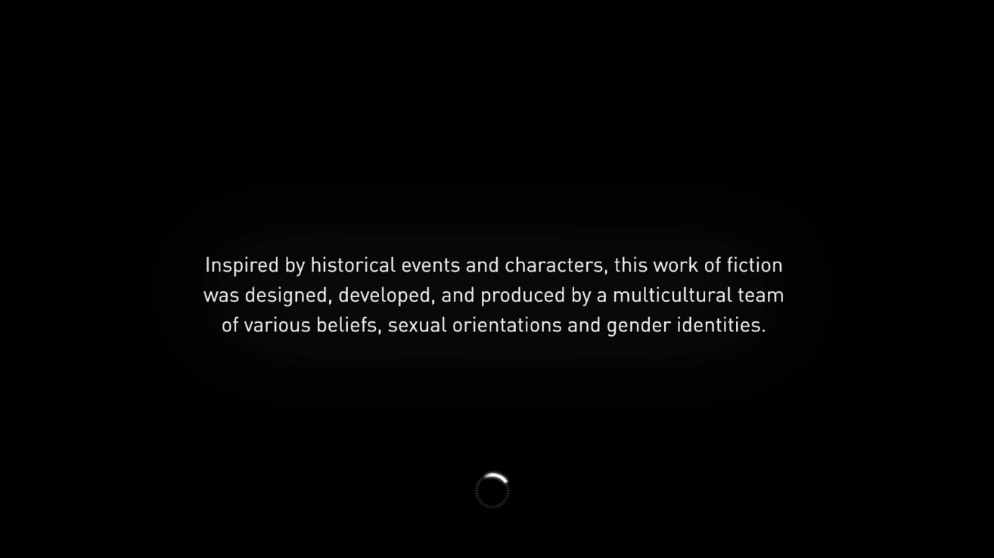

Individual countries blocking bleak parts of a countries history is a very common reason of censorship.

* In Germany, there is a ban on anything that resembles anything to do with the NSDAP, this ban extends further than games (‘Wolfenstein’ being banned from mentioning the party), though, banning anything in real life also.
* Battlefield 4 is banned in China as it discredited China’s national image as well as showing “Cultural invasion”, which they regard as a threat to national security.

POLITICS:

A lot of censorship doesn’t come down to if the game is overly gory or sexual it really depends on what your government thinks is acceptable at that time.

\*Open question to audience\*

“Do you have a line of what is and isn’t acceptable?”

“Is there anything that, if you knew was in the game, would make you not play it?”

* Rape?
* Child pornography?
* OTT gore?

EA SPORTS- You’d think a sports games would be exempt from censorship, nope.

MMA was not released in Denmark, not because of its violent nature but due to the advertising of energy drinks on the side of the ring.

Even games with ratings of 0+ can be censored, if you select German on FIFA 11,12 and 13 certain advertisements on team’s kits will be removed e.g. 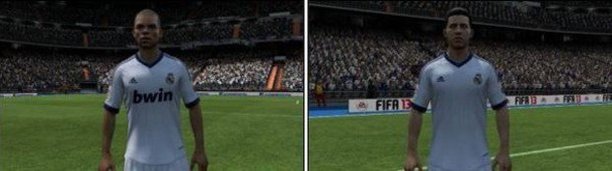

Looking at Xenoblade, a big Nintendo release from late last year – there was two changes in release for the American market, one of which is pictured here (not allowing a 13-year-old girl to wear a skimpy bikini) the other was that they took out the ability to change the breast size of the girl.

\*Question to the audience\*

“Is there such thing as child pornography when it is just pixels on a screen? Are the characters given age representative of anything real?

I think we can all agree there is a line, where that line is just a personal opinion, this makes it very hard for a governing body or a developer, even, to decide what is and isn’t acceptable but…….

Politics/ Violence crossover:

The protection of its citizens’ morals has always been at the centre of censorship. And for good reason, there are certain things that you don’t need to see in a game, manhunt 2 had a censored release due to the graphic nature of the kills (censored = <https://www.youtube.com/watch?v=smajP99B5xA>) (uncensored = <https://www.youtube.com/watch?v=x6LwaLHz5Xk>)

COMPARE to mortal kombat x where there is no bans on the game (<https://www.youtube.com/watch?v=2YxPFw7lfY0>)

\*Open question to audience\*

What do you think the difference between the games is?

* First person?
* Graphics?
* Reality?
* Moving with times?

FINANCIAL:

An example of financial gains for companies to censor their games comes in the form of total war: Warhammer, the original release for this game had no blood or gore, but they did later release DLC to add this into the game, this allowed them to look like they were ‘doing their bit’ for censorship but also allowed them to pick up an extra quid or 2 whilst doing so.

If a larger company feels they will generate substantially more sales for censoring parts of a game they will obviously also look to do so, in street fighter 5 they censored camera angles, so when one of the women is about to execute her finishing move they have a view of her ass but for the American release they moved the camera up as they thought this was too inappropriate